Topic: Optimizing Food Delivery Route Planning Using Dijkstra s Algorithm
Tripti Vishwakarma
Colorado State University Global
Course Code: CSC 506 1
Dr. Dong Nguyen
Jan 5, 2025

Title: Optimizing food delivery route planning using Dijkstra's Algorithm to find the shortest path for couriers considering real time traffic data

Introduction
The rise of food delivery services has necessitated efficient route optimization strategies to ensure timely deliveries and customer satisfaction. This project explores the use of Dijkstra's algorithm to optimize courier routes by determining the shortest paths in a network of roads while considering real-time traffic data. The implementation aims to enhance delivery efficiency and resource utilization in urban environments.

Purpose
The primary goal of this project is to utilize Dijkstra's algorithm to dynamically optimize delivery routes based on real-time traffic conditions. By modeling a city's road network as a graph, where intersections are nodes and roads are weighted edges reflecting traffic conditions, the algorithm calculates the most efficient path for couriers. This approach seeks to minimize delivery times and improve the overall efficiency of food delivery services.

Algorithm Implementation
The following Python implementation of Dijkstra's algorithm allows for dynamic user input to define the graph's nodes and edges, which represent intersections and roads, respectively. This setup is designed to consider real-time traffic data adjustments.

Source Code-

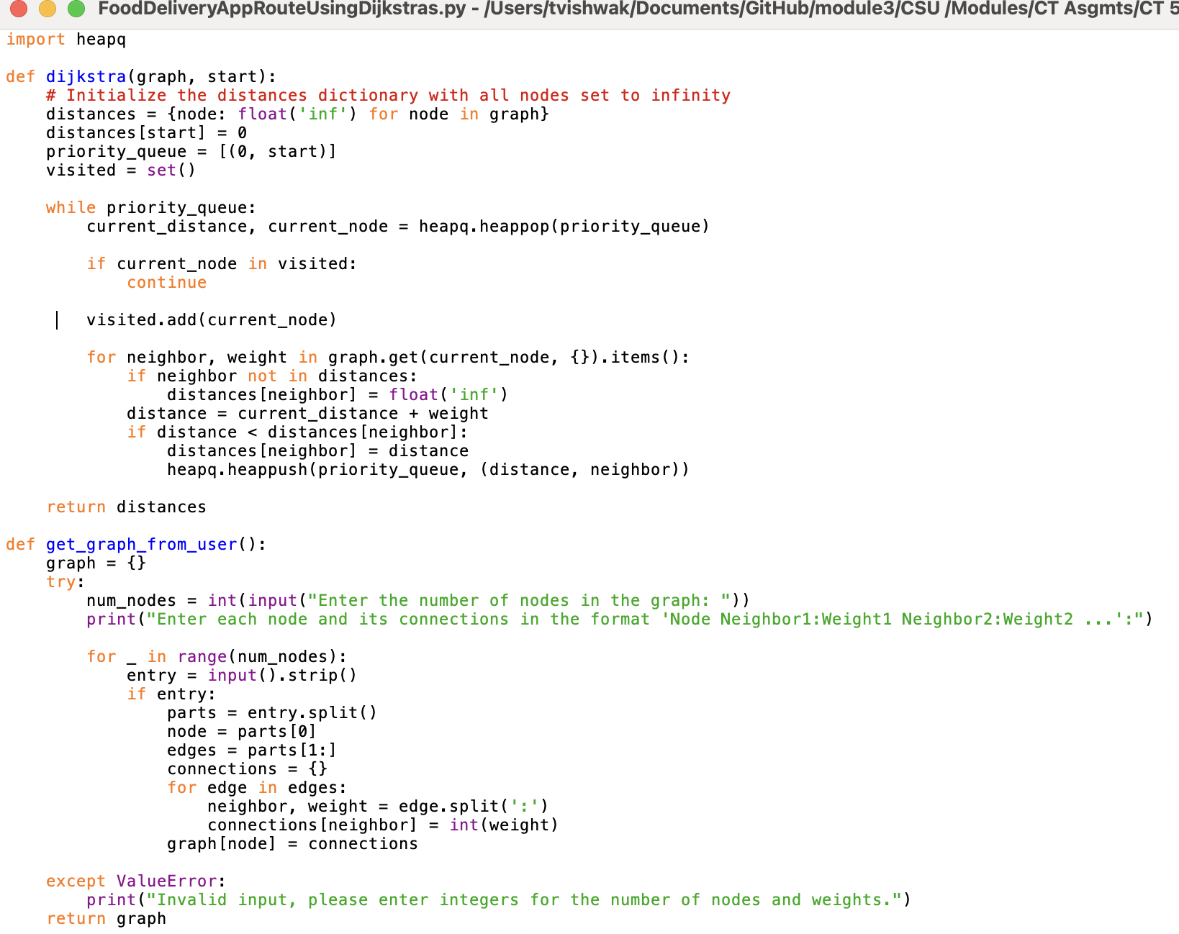
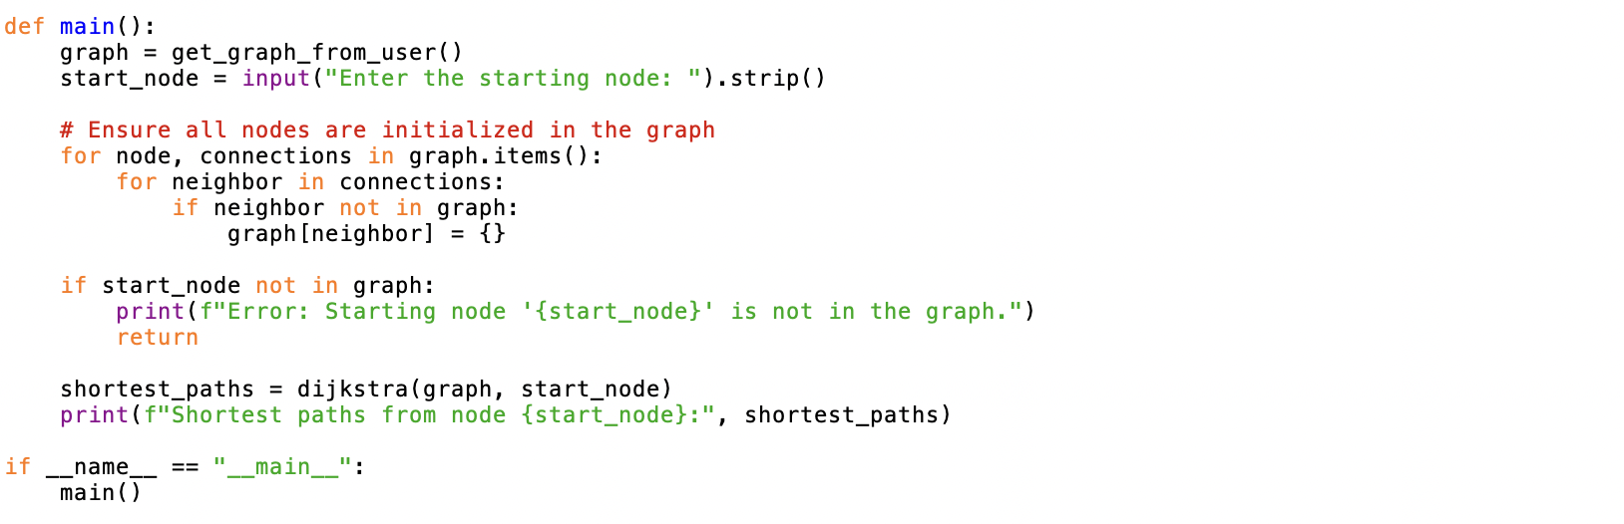

Execution-

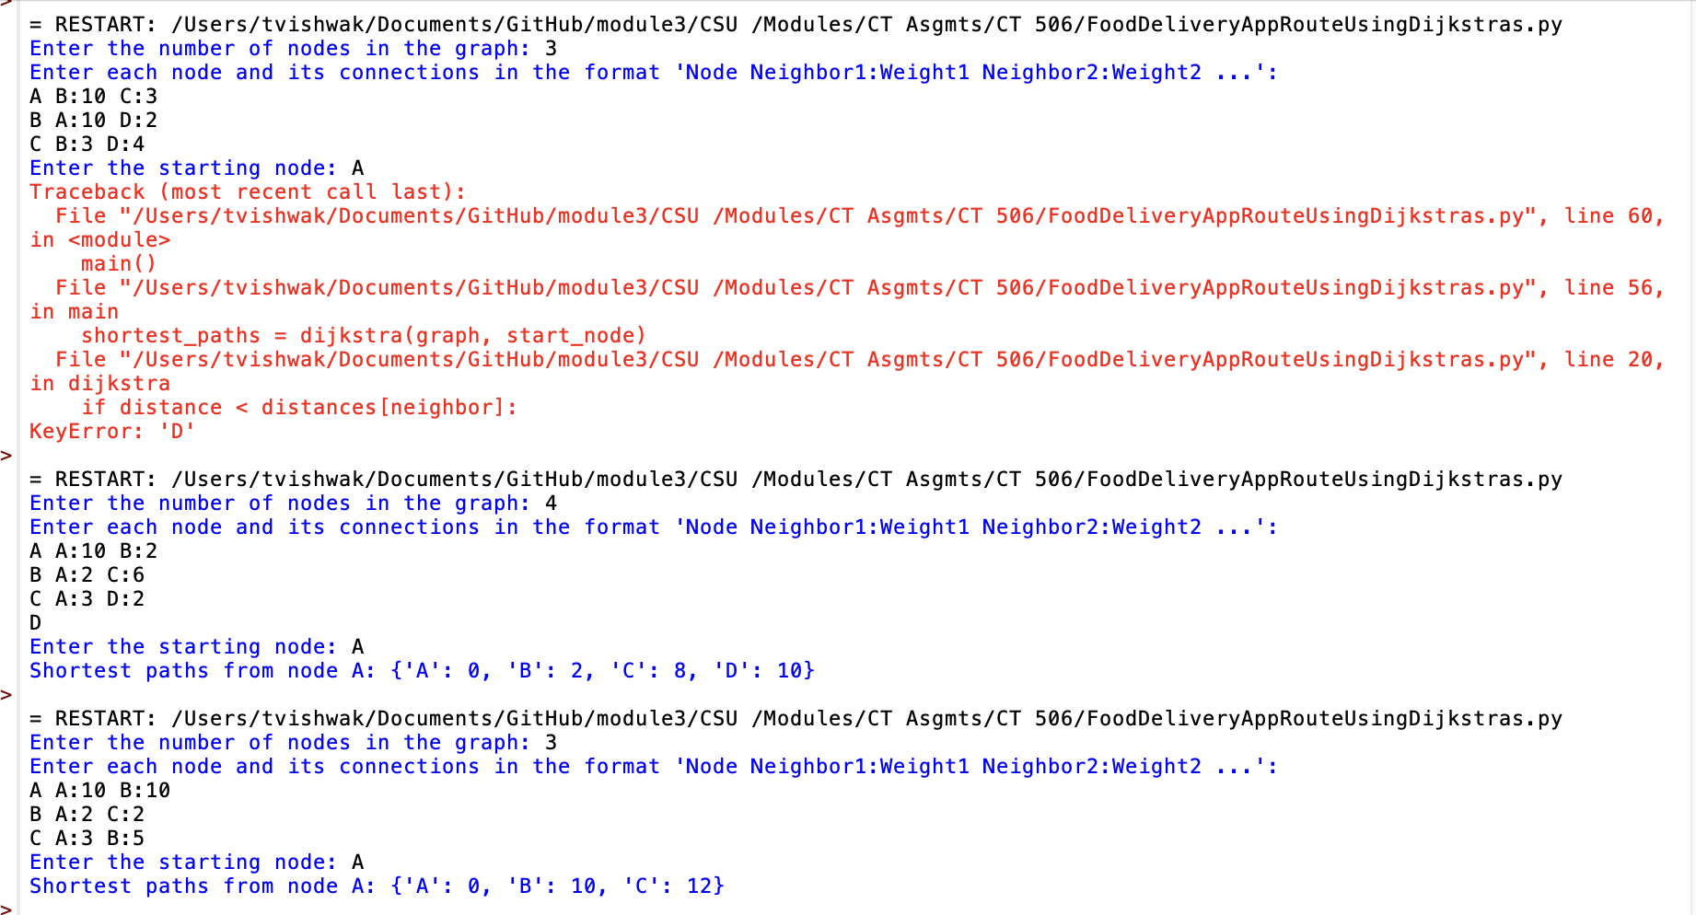

Obstacles Faced
Throughout the development of this project, several challenges were encountered:
- Dynamic Traffic Data Integration:
  - Real-time traffic data integration posed a challenge due to the need for constant updates to the graph's edge weights, requiring efficient handling of data updates to maintain route accuracy.
- Graph Completeness:
  - Ensuring that all nodes, including those only mentioned as neighbors, were properly initialized in the graph was a key challenge. This required additional logic to automatically initialize nodes that were not explicitly defined.
- Scalability:
  - Handling larger graphs with numerous nodes and edges while maintaining algorithm efficiency was essential. Optimizing the algorithm to handle increased data without degrading performance was a critical task.
Skills Acquired
The project facilitated the development and enhancement of several skills:
- Algorithm Design and Implementation:
  - Gained a deeper understanding of graph theory and pathfinding algorithms, particularly in the context of real-world applications.
- Real-Time Data Processing:
  - Developed skills in integrating and processing real-time data, crucial for ensuring responsive system behavior in dynamic environments.
- Problem-Solving and Debugging:
  - Improved ability to troubleshoot and resolve errors, such as handling KeyError by ensuring all graph nodes are properly initialized.
- Scalability and Performance Optimization:
  - Learned techniques for optimizing algorithm performance to handle larger datasets efficiently.

Applicability of Dijkstra's Algorithm
Dijkstra's algorithm is well-suited for static graphs with non-negative weights, making it ideal for initial route planning in urban road networks. However, its applicability in dynamic environments, such as real-time traffic systems, requires frequent recalculations to adapt to changing conditions.
Time Complexity Analysis
The time complexity of Dijkstra’s algorithm is (O((V + E) \log V)), where (V) is the number of vertices and (E) is the number of edges. This complexity is influenced by the frequency and volume of traffic updates, necessitating efficient data management to maintain performance.
Real-Life Variables Impacting Performance
- Traffic Variability: Constant changes in traffic conditions require frequent graph updates, impacting computational demands and algorithm performance.
- Road Closures/Accidents: Sudden changes in road availability necessitate immediate route recalculations.
- Delivery Constraints: Specific delivery time windows introduce additional complexity beyond what Dijkstra's algorithm handles inherently.

External Factors Influencing Efficiency
- Data Accuracy: The accuracy and timeliness of traffic data significantly affect route planning reliability.
- Network Connectivity: Delays in data updates due to connectivity issues can hinder real-time route adjustments, affecting delivery efficiency.
- Computational Resources: The availability of processing power on devices impacts the algorithm's ability to scale and respond quickly to changes.

Conclusion
This project demonstrates the potential of Dijkstra's algorithm for optimizing route planning in food delivery services. While effective as a foundational tool, real-world applications necessitate enhancements to accommodate dynamic traffic conditions and additional constraints. Future work could explore hybrid models or machine learning approaches to further improve adaptability and efficiency in route optimization.

References

Cormen, T. H., Leiserson, C. E., Rivest, R. L., & Stein, C. (2009). Introduction to Algorithms(3rd ed.). MIT Press.
Dijkstra, E. W. (1959). A note on two problems in connexion with graphs. Numerische Mathematik, 1(1), 269-271. https://doi.org/10.1007/BF01386390
Golden, B. L., Raghavan, S., & Wasil, E. A. (Eds.). (2008). The Vehicle Routing Problem: Latest Advances and New Challenges. Springer. https://doi.org/10.1007/978-0-387-77778-8
Wardrop, J. G. (1952). Some theoretical aspects of road traffic research. Proceedings of the Institution of Civil Engineers, 1(3), 325-362. https://doi.org/10.1680/ipeds.1952.11259
Zhan, F. B., & Noon, C. E. (1998). Shortest path algorithms: An evaluation using real road networks. Transportation Science, 32(1), 65-73. https://doi.org/10.1287/trsc.32.1.65

